Partial Statement of Account Report

|  |  |  |  |  |
| --- | --- | --- | --- | --- |
| **Ver** | **Date** | **Author** | **Comments** | **Reviewed by** |
| 1 | 13/11/2020 | Tom Bell | CRIM 0332 | TBC |
|  |  |  |  |  |

Requirements 2

Prerequisites 2

Solution Overview 2

Solution Details 2

Security 3

Companies 3

Data Migration 3

Test Steps 3

Technical Implementation 3

Requirements

The system must have a Partial Statement of Account Report, triggered from CRIM event C0333.

Prerequisites

* Aging Buckets Modification CRIM (CRIM C0330).
* Customer Statement of Account Report C0331

Solution Overview

**Context:** A Customer would like a reminder of what items are outstanding on their account. However, they would like a statement for one or more two invoices on their account. Credit Control can issue a Partial Statement of Account to the customer showing only selected invoices.

The guiding principle for this “Partial Statement of Accounts” report, is to use the AS IS report as a rough template and add a PO Number column and to remove the Remittance Slip section, whilst keeping Tunstall Bank Details on the report.

The Partial Statement of Account differs from the Full Statement as at the bottom of the report it needs the line “This may not include all open items currently on your account”. As well as a text title at the top of the report stating that it is a “Partial Statement of Account”.

As of 08/07/2021 CRIM 0331 is in development. When this report is complete, the report can simply be copied, and the following changes be made.

* Disclaimer text hard coded onto document. “Partial Statement of Account - this may not include all open items currently on your account”
* Change document title to Partial Statement of Account.
* Trigger for this report be changed to the trigger as discussed below.

Solution Details

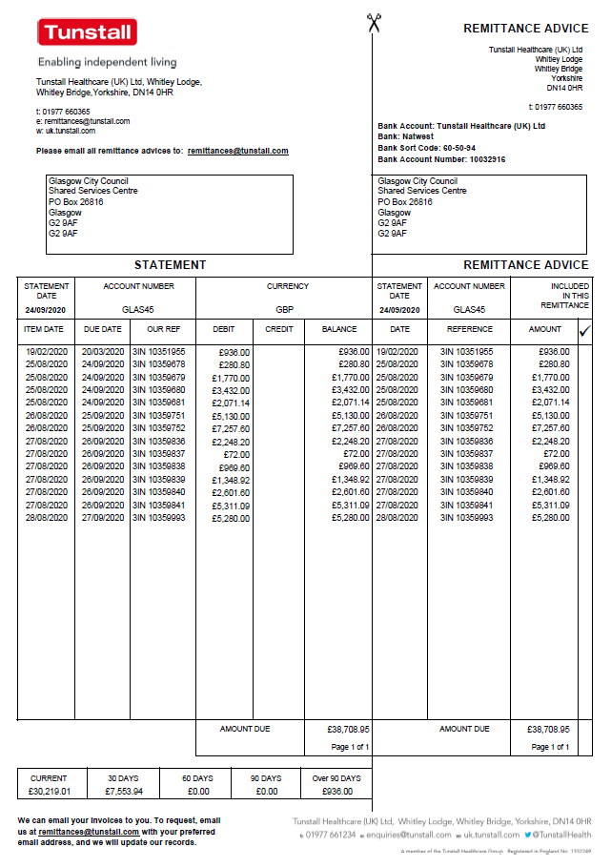

The above screenshot shows an example of a “Statement of Account Report” that currently sent out to customers. The Remittance Slip section is now obsolete and is no longer needed and PO Number column is needed. Tunstall’s bank details are still required in the new report. Additionally, near the bottom of the report the text “This may not include all open items currently on your account” is required.

**Summary of Changes from AS IS Statement**

* Add PO Number column.
* No remittance slip (keeping only Tunstall’s bank details from this section).
* Disclaimer text hard coded onto document. “Partial Statement of Account - this may not include all open items currently on your account”

**Trigger of Partial Statement**

CRIM 0332 is a linked to this one. 0332 CRIM that allows a user to select individual items for a quick report. This Partial Statement Report needs to be mapped from these items so when the report is ran the items are in the report.

RMB item(s) to include in statement and select “Select for Quick Report”.

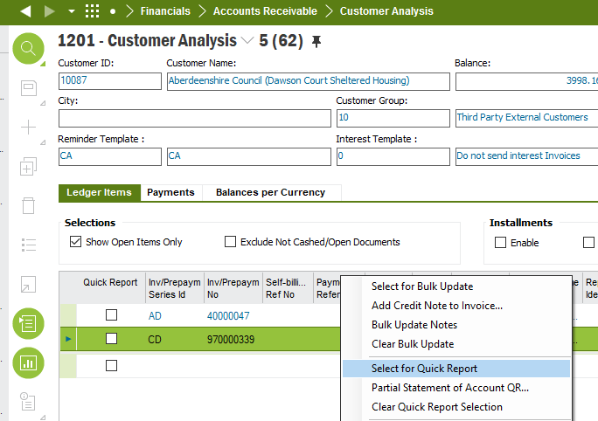

RMB again and select “Partial Statement of Account”.

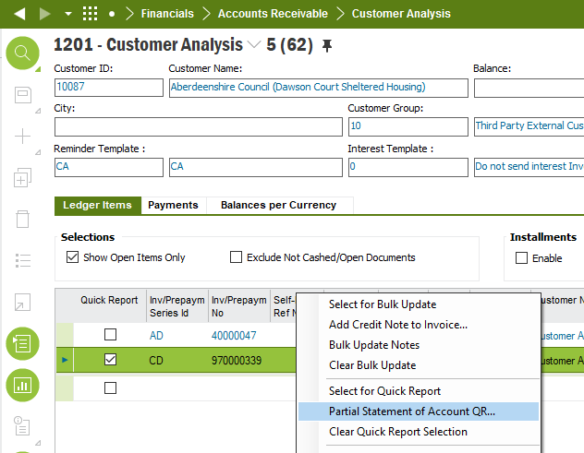

Require a way to map this item(s) into the Partial Statement Report (this spec). Once mapped the statement must then be able to be printed and emailed to the customer.

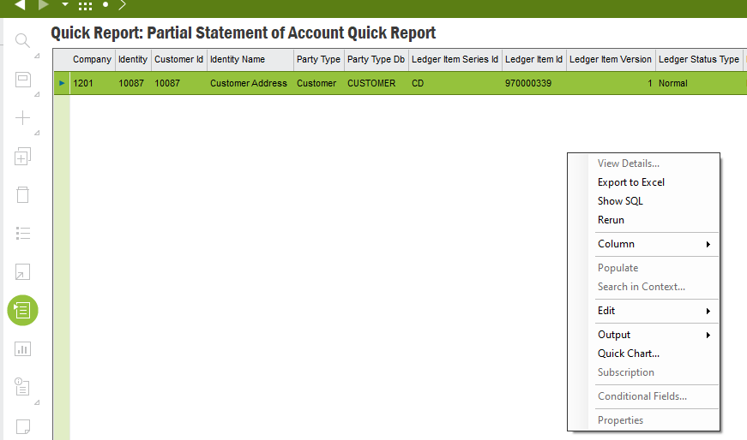

Document Formatting

All text fonts and colours should be as per company branding:

Text Font: Headers should use **Calibri Bold (Body)** , all other text font Calibri (Body).

Text colour should be black.

Document Name: Customer Partial Statement of Account

**Please see CRIM 0331 for formatting this document can be copied. Below is a working screenshot of the C0331.**

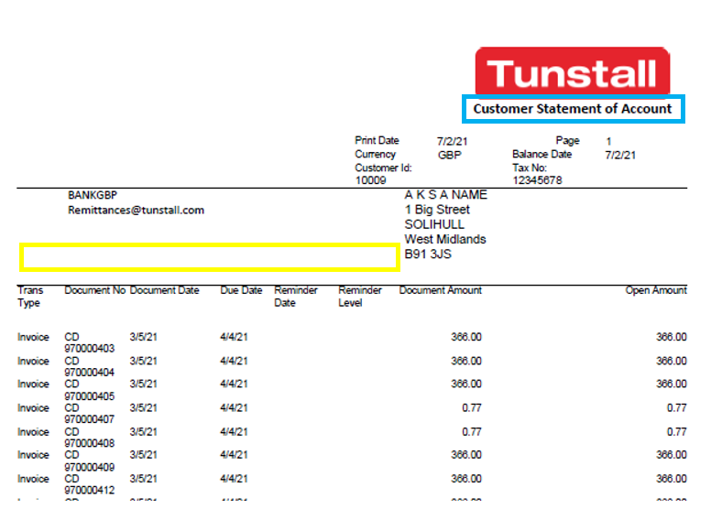

**Blue Box** – Needs to reflect the document title “Customer Partial Statement of Account”

**Yellow Box** – requires disclaimer “Partial Statement of Account - this may not include all open items currently on your account”

# IFS Customer Statement of Account Report (Annotated)

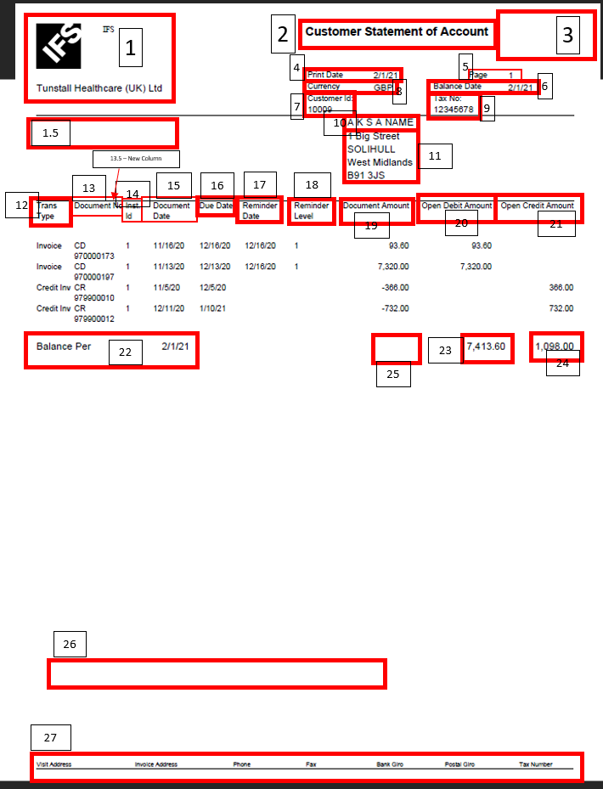

# Column Order

The below table shows the desired column order. The columns and their content have been described in the below section.

|  |  |  |  |  |  |  |
| --- | --- | --- | --- | --- | --- | --- |
| **Document Date**  Field 15 | **Due Date**  Field 16 | **Document Number**  Field 13 | **PO Number**  Field 13.5 | **Debit Amount**  Field 20 | **Credit Amount**  Field 21 | **Balance**  Field 19 |

# Report Column and Field Details

* **Field ID** = corresponds to the number on the “IFS Customer Statement of Account Report (Annotated)” report.
* **Field Name** = what the name of the field in the new report.
* **Field Name/Data Source** = shows where the data can be found in IFS plus any extras details where calculations/logic are needed.
* **Additional Notes** = any extra information or notes
* **Disclaimer hard cod ethe following text– “Partial Statement of Account: This may not include all open items currently on your account”**

|  |  |  |  |
| --- | --- | --- | --- |
| **Field ID** | **Field Name** | **Field Name / Data Source** | **Additional Notes** |
| 1 | REMOVE – IFS logo and text | REMOVE – Remove IFS logo and text. |  |
| 1.5 | Bank Details | Tunstall’s bank details must be included in this statement so that Customer’s know what bank details to use when they pay Tunstall. Send where this data is located in IFS. | This must be incldued in the report.  Matt to look at. |
| 1.6 | Email address. | Remittances@tunstall.com | This email address must be below the Bank Details (field 1.5) |
| 2 | Document Name | Move to under the logo (see field 3) |  |
| 3 | Logo | **Document Title = “Customer Statement of Account”** | This should be located at the far right of the header.  “Customer Statement of Account” should be located under the logo. |
| 4 | Print Date | Date the statement was printed. |  |
| 5 | Page No. | If more than one page then “Page 1 of X” | Curent page in the report plus any other |
| 6 | Statement Balance Date | This is the date that the statement was generated for. | Automatically set to today, unless specificed otherwise. |
| 7 | Customer ID |  | ID of the customer for that statement. |
| 8 | Currency | Currency on the ledger item? Nope.  Curency – | The currency that the invoices are due. |
| 9 | REMOVE | REMOVE | Remove the Tax Numbe field. |
| 10 | Customer Name |  | Customer Name.  The customer name should be located above the Customer Address (disccused in the next seetion). |
| 11 | Customer Address |  | Use the address where the Address Type default address is “PAY” in the Customer Record. |
| 12 | REMOVE – “Trans – Type Column” | REMOVE “Trans Type Column” |  |
| 13 | Document Number | Column Header called “Document Number”. Containing the list of Open Item Documents within the Customer Analysis screen.  The below shows the same data at invoice level. | The unique ID for an Invoice. Include the Invoice Number as well as the Invoice Series ID. |
| 13.5 | **New Column -**  Purchase Order Number |  | The PO Number that the Invoice links to should be listed here if available.  You can access this screen by RMB-ing on a line in the Customer Analysis screen and selecting “Customer Invoice Analysis”. |
| 14 | REMOVE | REMOVE “Int. ID” column | REMOVE |
| 15 | Document Date | This column requires data for every invoice in the customer analysis screen. It must contain the Date Date for every open invoice on the customer’s account. | Rename to “Invoice Date” |
| 16 | Due Date | This column requires data for every invoice in the customer analysis screen. It must contain the Due Date for every open invoice on the customer’s account. |  |
| 17 | Reminder Date- REMOVE | Remove Reminder Date Column |  |
| 18 | Reminder Level- REMOVE | Remove Reminder Level Column | The date that the invoice ammount is due for payment by. |
| 19 | Document Ammount – Invoice Ammount | This column will show the Invoice Amounts on the Invoices. |  |
| 19.5 | New Column = Balance | This column will show the Open Amount/Balance on an Invoice. |  |
| 20 | Debit Amount | If the Document Amount/Balance column (see field 19) is postive e.g. “100” then the it is a debit amount and should be shown in this column. | Debit Lines for the invoice. These columns are in the IFS report already. |
| 21 | Credit Amount | If the Document Amount/Balance (see field 19) is negative e.g. “-100” then the it is a credit amount and should be shown in this column. | Credit for the invoice. These columns are in the IFS report already see the IFS exmaple for more details. |
| 22 | REMOVE | REMOVE – Balance Date |  |
| 25 | Total Amount Due - | Sum of items in balance column. | Located under the Balance column. This is the total of all invoices on the Statement. Sum of all the invoice balances. |
| 23 | Remove | Debit Total. Please remove. |  |
| 24 | Remove | Credit total Total. Please remove. |  |
| 26 | Aging Buckets | The below screenshot shows the Aging Buckets on the current statement and how they’re set out. This must be replciated but with the data from the above screenshot in IFS. | Aging Bucekts 1,2,3,4,5,6 must be incldued.  Names of buckets should be set out as per the below screenshot to the left. i.e “Current”, “30 DAYS” etc. |
| 27 | Tunstall Document footer |  | Add to bottom right hand corner of each page by default.  Send screenshots of where the data is held in IFS.  Field where we can put this as a logo on the company tab or soemting. |
|  |  |  |  |

Delivery Notes

1. Import ACP package EA_FINANCE

This contains two custom fields required for the report.

1. Publish the ACP if it’s not published.
2. Go to Report Definition select the report and create a new line for partial layout.

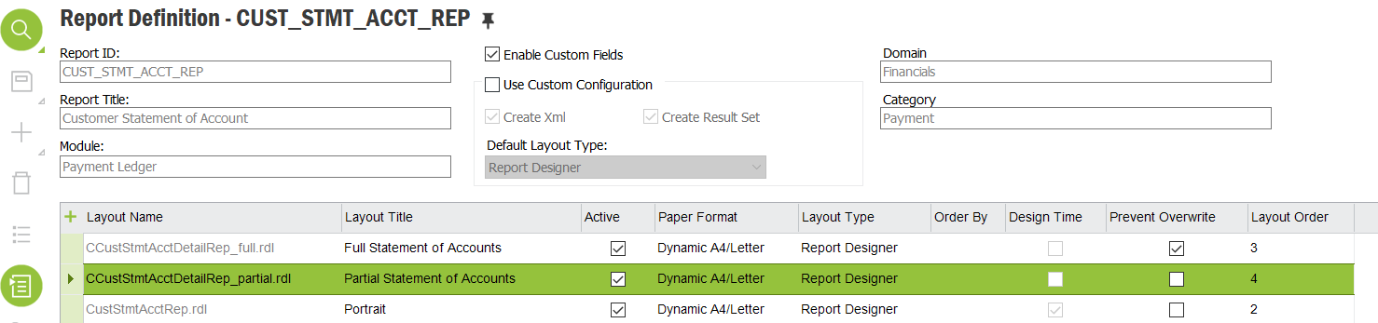

1. RMB on the line -> ‘Import Layout’ and import the CCustStmtAcctDetailRep_partial.rdl file.

Pre-requisites

* Tunstall LOGO in the correct location
* Document footer configured
* Custom field ‘override Invoice’ is imported (should have added via C331 CRIM)

Note : The footer change is mentioned later in another document

*CRIM_0332_-_IFS_Configuration_Specification_-_Partial_Statement_of_Account_Report v0.2-Amendment.docx*

Field Definitions.

<New Field/CLU Definition>

|  |  |  |  |  |  |  |
| --- | --- | --- | --- | --- | --- | --- |
| New DB Object Name | DB Object Item/Field Names | Item Description | Item Data Type | Item Syntax | Calculation Spec, if Derived | LOVs/Enums/Is Mandatory? |
|  |  |  |  |  |  |  |
|  |  |  |  |  |  |  |
|  |  |  |  |  |  |  |
|  |  |  |  |  |  |  |
|  |  |  |  |  |  |  |
|  |  |  |  |  |  |  |
|  |  |  |  |  |  |  |
|  |  |  |  |  |  |  |
|  |  |  |  |  |  |  |
|  |  |  |  |  |  |  |
|  |  |  |  |  |  |  |
|  |  |  |  |  |  |  |

Security

<Define security controls> (Who needs access to this and will it be restricted from any other users etc)

* Finance Manager.
* Credit Manager.
* Credit Controllers.

Companies

Applies to the following companies. All.

|  |  |
| --- | --- |
| **Company** | **Required (Y/N)** |
| 1201 | Y |
| TBC |  |
|  |  |

Data Migration

<Describe any data migration impacts this development may have – i.e additional data to be migrated>

Test Steps

<Steps that needs to be taken to test this change. Please provide expected results> Updated post solution.

|  |  |  |
| --- | --- | --- |
| **No** | **Script\Test Steps** | **Expected Result** |
| 1 | Open a Partial Statement of Account report. | See the fields as detailed in Solution Detail table. |
| 2 |  |  |
|  |  |  |
|  |  |  |
|  |  |  |
|  |  |  |

Technical Implementation

<Completed by the technical developer - Technical solution, list packages, functions, Custom menus created etc >